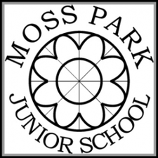
Year 5
Spring Term
Essential Word List

These words have been taken from the Y5 and Y6 National Curriculum spelling appendix. They do not necessarily follow a spelling rule and can be classed as ‘tricky’ words. Children will be tested on these words throughout the term and should practise them at every opportunity as part of their ongoing homework. We will let you know which ones your child found difficult after each test so that you can focus on those words. Thank you.

ancient  bruise  conscious  desperate  dictionary  environment  excellent  explanation  foreign  government  individual  interrupt  language | leisure  lightning  marvellous  mischievous  muscle  necessary  parliament  physical  rhyme  rhythm  stomach  twelfth  yacht

Year 5
Summer Term
Essential Word List

according  aggressive  attached  available  bargain  competition  convenience  definite  especially  familiar  forty  frequently  hindrance | These words have been taken from the Y3 and Y4 National Curriculum spelling appendix. They do not necessarily follow a spelling rule and can be classed as ‘tricky’ words. Children will be tested on these words throughout the term and should practise them at every opportunity as part of their ongoing homework. We will let you know which ones your child found difficult after each test so that you can focus on those words. Thank you.  identify  immediate  opportunity  profession  pronunciation  nuisance  recognise  recommend  restaurant  suggest

