Science Curriculum
MOSS PARK PRIMARY SCHOOL - 2023-2024
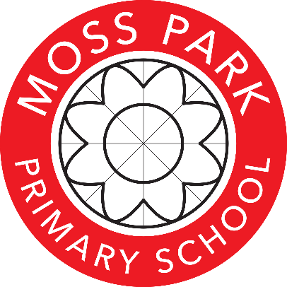
Year group | Autumn Term 1 | Autumn Term 2 | Spring Term 1 | Spring Term 2 | Summer Term 1 | Summer Term 2
Nursery | Our Bodies  We will learn about our bodies and senses | All about me  We will describe our physical features | Natural Growth  We will investigate our natural environment | Animals  We will observe the lifecycle of a caterpillar | Plants and Animals  We will plant seeds and observe changes using scientific vocabulary | World we live in  We will observe and comment on change in our immediate environment
Reception | Explore how water moves through flowers and plants | Explore and understand seasonal changes | Experiments for cause and effect – prediction | Understand the life cycle of a chick Spring | Growing and change To understand why we need rain | Growing and change To understand why we need to grow
Year 1 | Animals including humans  Who am I? | Celebrations | Polar Places | Plants and animals  Plants, animals and where we live | Animals including Humans  On Safari | Holiday
Seasonal change
Ran across the year at regular intervals recording observations and discussions in ‘Big Book’ approach
Year 2 | Animals, including Humans  Our bodies | Everyday materials  Materials Monster | Everyday materials  Squash, bend, twist and stretch | Living things and their habitats  Our Local Environment | Plants  Young gardeners | Animals including humans  Little master chefs
Year 3 | Plants  How does your garden grow? | Animals, including humans  Food and our bodies | Light  Lights and shadows | Rocks  Rocks and fossils | Forces and magnets | STEM  The nappy challenge
Year 4 | Sound  What’s that sound? | Animals, including Humans  Living things | States of matter  Looking at states | Animals, including Humans  Teeth and easting | Electricity  Power it up | Living things and their habitats  The big build
Year 5 | Earth and Space  Out of this world | Properties and changes in materials  Material World | Living things and their habitats  Circle of life | Forces  Let’s get moving! | Animals, including humans  Growing up and growing old | Living things and their habitats  Amazing Changes
Year 6 | Living things and their habitats  Classifying Living Things | Animals, including Humans  Healthy Bodies | Evolution and inheritance | Light | Electricity | Working scientifically  The Titanic

